B
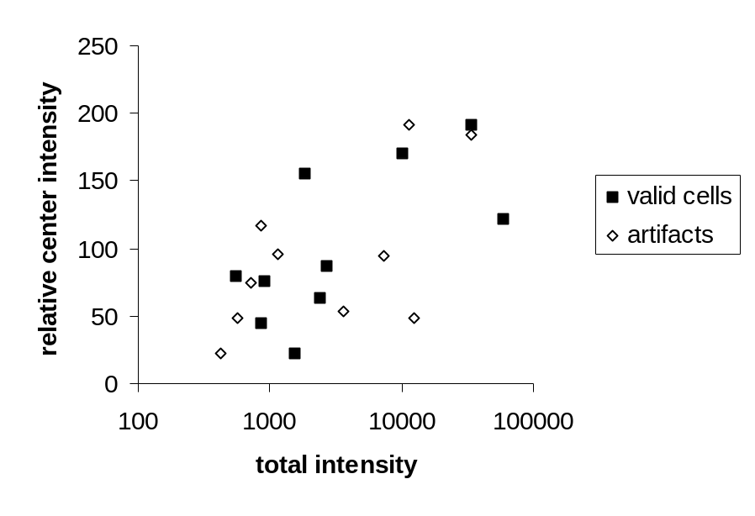
Supplemental Figure 1 (A) Examples of images for five different localization classes (from top to bottom: cyto-nuclear, nuclear lamina, peroxisomes, ER, and nucleoli). In the first two columns valid subcellular classes are shown. In the third and fourth column artifacts with underexpressed, overexpressed, or cut protein signals are shown. (B) Intensity plot of images shown in (a). Logarithmic scale of total intensities on the x-axis versus relative center intensities on the y-axis is depicted. Evidently, intensity cannot serve as a parameter to distinguish between artifact and valid cells.

